Snow-flake Curve
We start with an equilateral triangle:

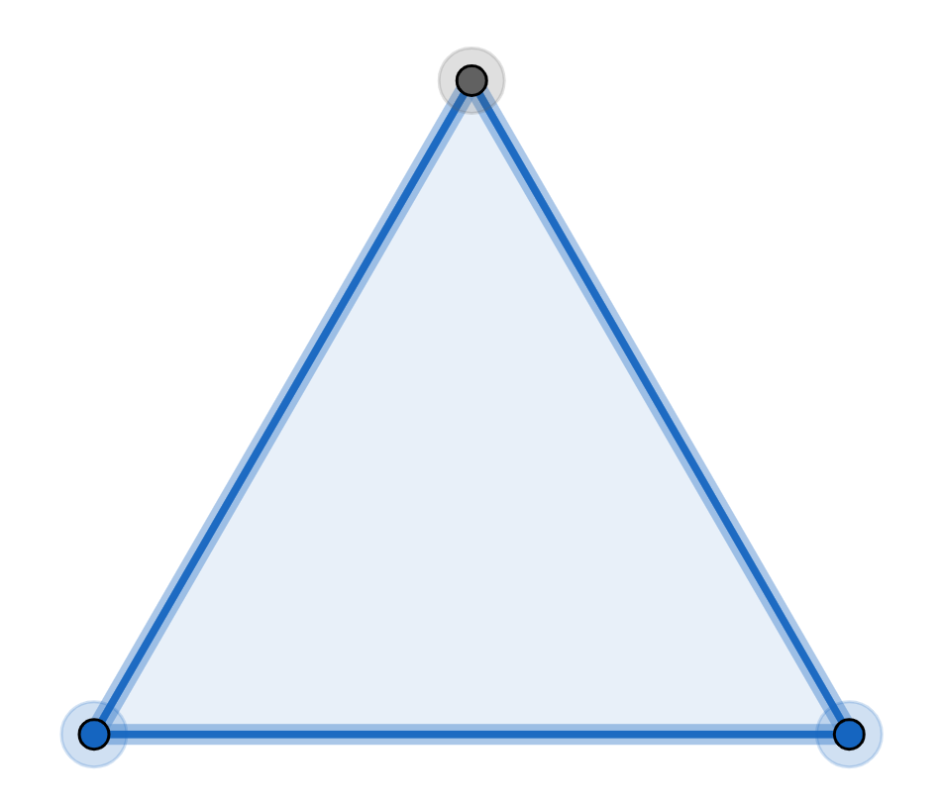

Then we add a smaller equilateral triangle to each of the three sides:

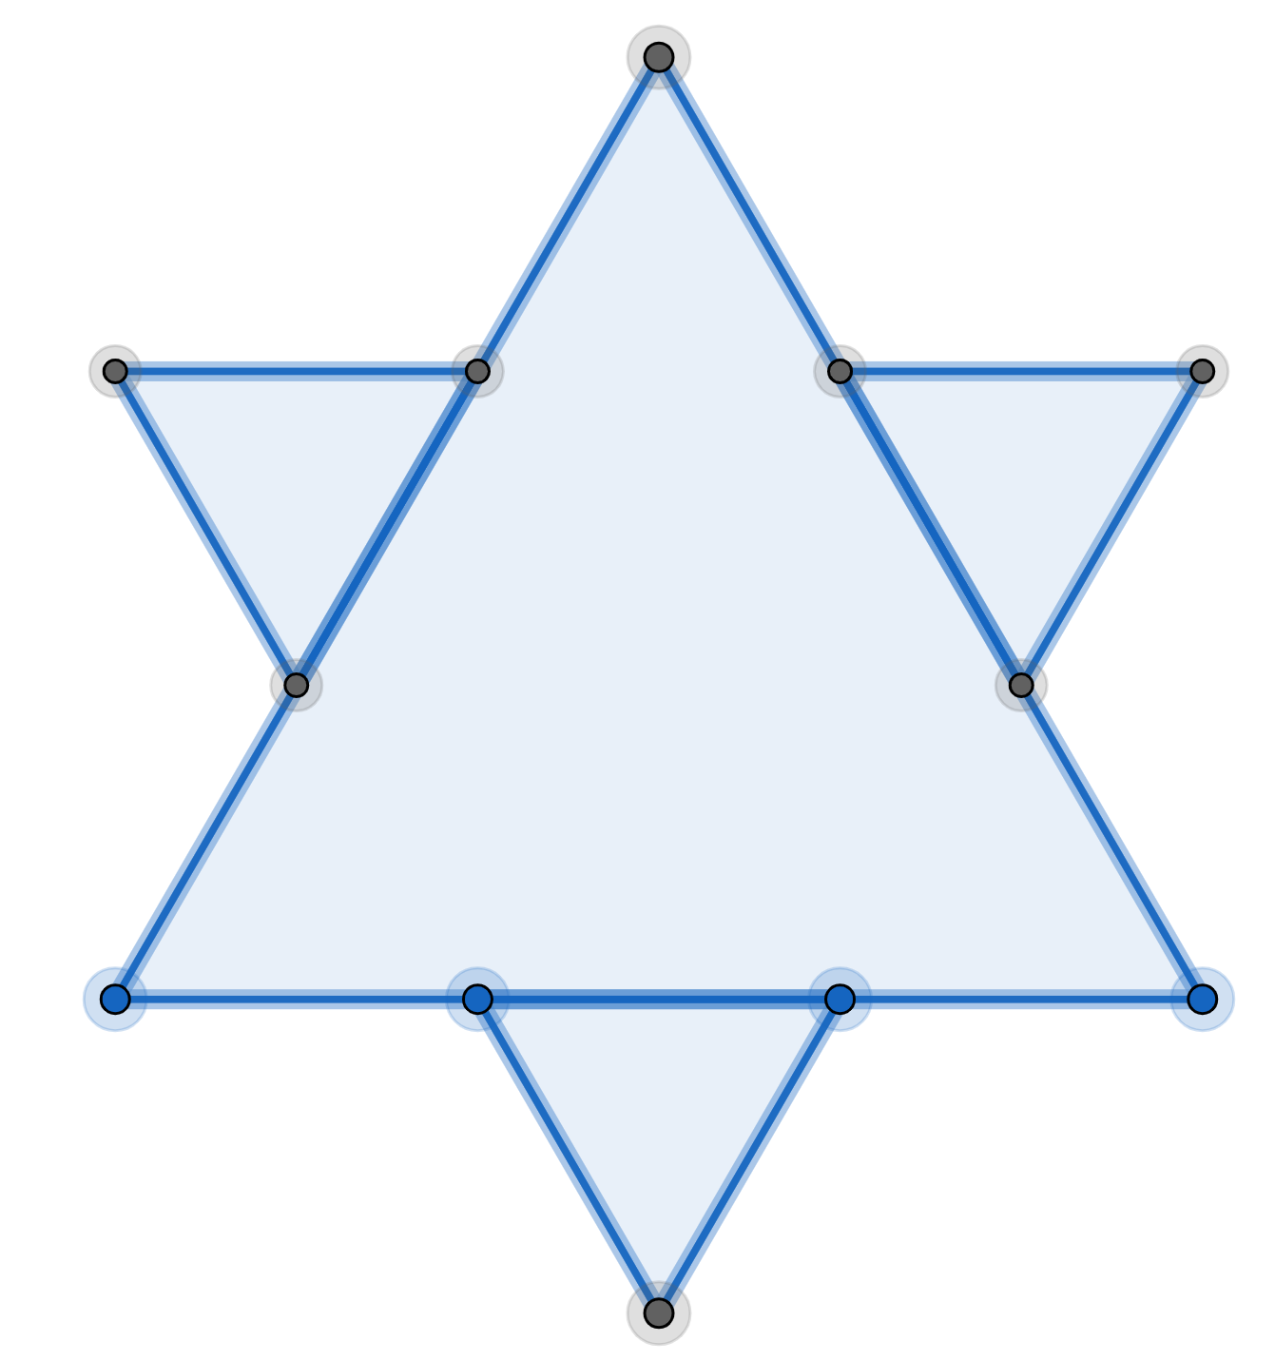

Then we add an even smaller equilateral triangle to each of the twelve sides.
We repeat this an infinite number of times to get the snowflake curve. We want to find the perimeter and area of the this curve.

Perimeter
At the start, we have 3 sides of lengthso the perimeter is
The first iteration replaces each side by 4 sides of lengthso the perimeter is
Each iteration increases the perimeter by a factor of
So after an infinite number of iterations, the perimeter is infinite.

Area
At the start, we have a triangle with area
The first iteration adds 3 triangles, each of area
The second iteration addstriangles, each of area
The third iteration addstriangles, each of area
etc
So after an infinite number of iterations, the area is:

Now:
(see Appendix 2: Geometric Sequence)
So the final area is:

So the snow-flake curve has a finite area but an infinite perimeter.

